**Introduction**

**Edu Map** is an AI-powered platform that supports the development and assessment of **Social and Emotional Learning (SEL)** skills in students. Based on the **CASEL framework**, it offers interactive simulations, real-time analytics, and personalized feedback using **Claude AI**.

The platform features a dual interface for **educators and students**—educators can manage classes and track progress, while students engage with simulations to build core SEL competencies like self-awareness and decision-making.

Edu Map enables schools and educators to make informed decisions, foster emotional intelligence, and promote long-term student success — all within an intuitive, data-driven environment.

**Navigation Guide**

**Start Page:**Choose your role to access AI-powered SEL tools and personalized dashboards. Both students and educators have dedicated Login, Register, and Forgot Password pages for secure access and account management.

**Student's navigation:**

* **Home**: See available classes with codes, subjects, and “Start Simulation” buttons. Search classes and view recent activities.
* **My Simulations**: view all completed simulations. Search for classes and click “View Details” to review your past attempts and scores.
* **My Progress**: Track skill development with charts, summaries, and exportable PDF reports.

**Educator's navigation:**

* **Home:** Personalized dashboard showing active classes, students, topics, and recent actions, with quick links to create classes, manage them, or view progress.
* **My Classes:** List of classes with details and options to view summaries, reports, or delete classes.
* **Student Progress Overview:** Overview of all students’ simulation attempts, scores, and activity with detailed views.
* **Create Class:** Create new classes with AI-generated CASEL-based simulations by entering class info and topic.

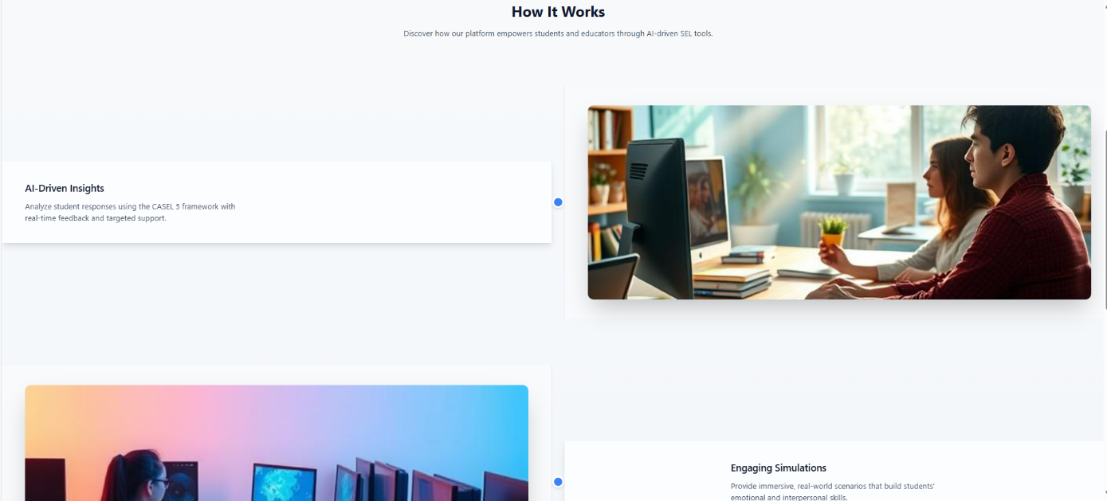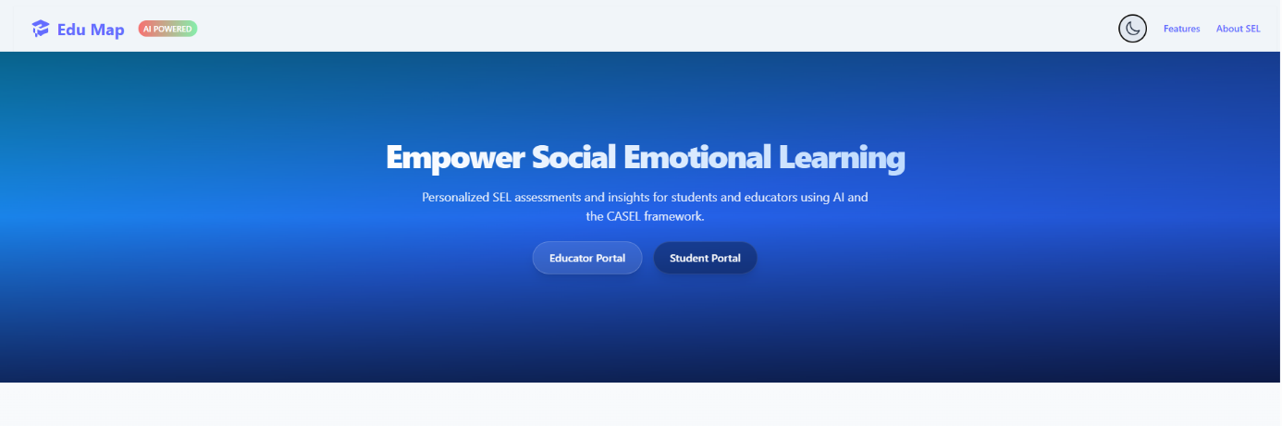**Home Page:**  
Features two main login buttons for students and educators that navigate to their respective login pages, a header with quick access to Features and About SEL, a dark/light mode toggle, and a short platform introduction.

Clicking on **Features** opens a popup window displaying detailed information about the platform’s capabilities.

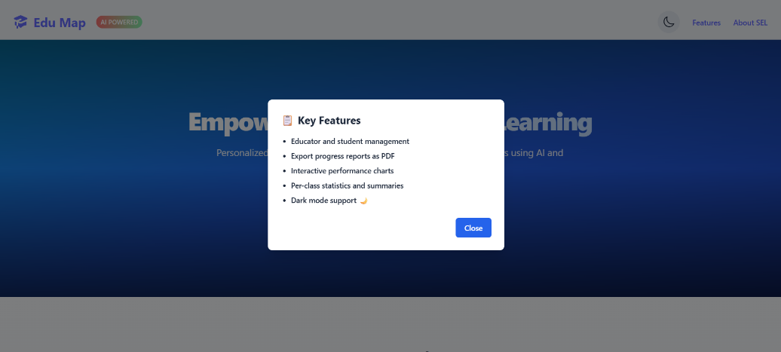

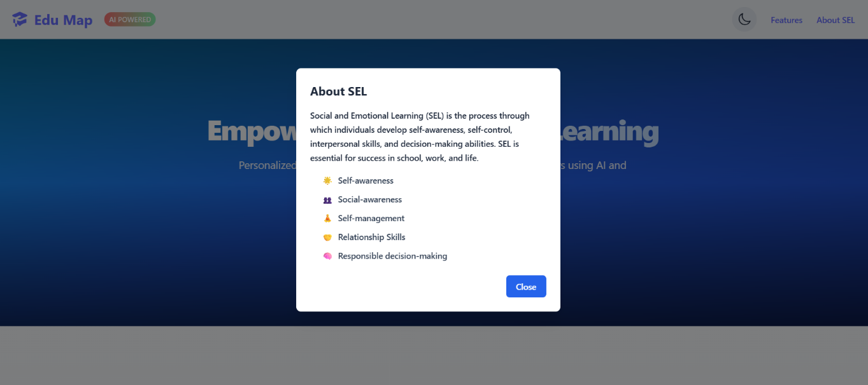Clicking on "About SEL" shows a popup explaining Social Emotional Learning.

תמונה שמכילה צילום מסך, אדם

תוכן שנוצר על-ידי בינה מלאכותית עשוי להיות שגוי.תמונה שמכילה טקסט, צילום מסך, תוכנה, מערכת הפעלה

תוכן שנוצר על-ידי בינה מלאכותית עשוי להיות שגוי.and toggling the dark/light mode switches the site’s theme accordingly

**Student's Pages:**

**Login page:**

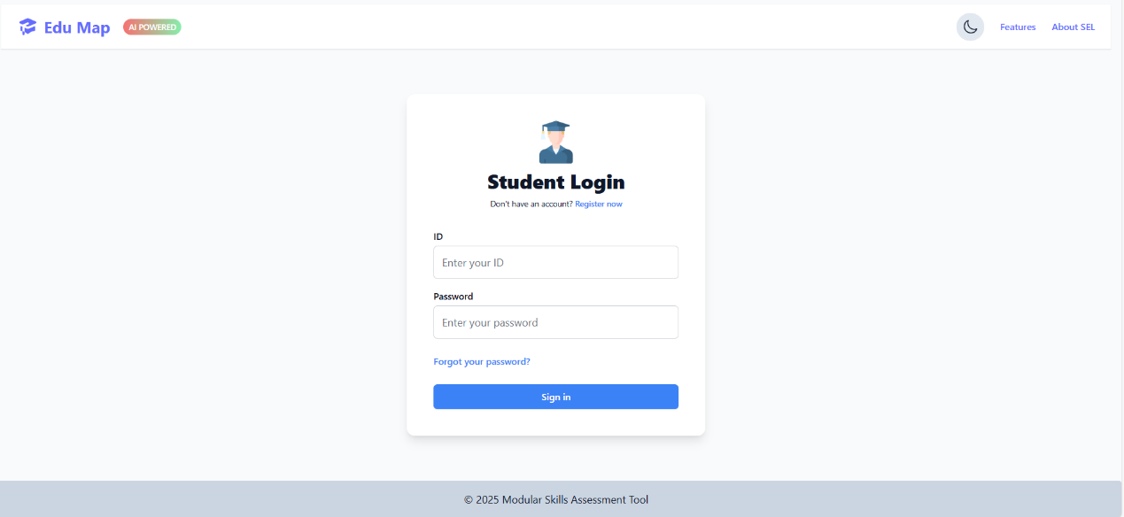The Student Login page allows students to enter their ID and password to access the system. It also includes options to register for a new account or select "Forgot your password?" if needed.

The Student Registration is a two-step process: enter basic, then optionally upload a profile picture or skip. Finish by clicking Register. A link is available to switch to the Sign in page.

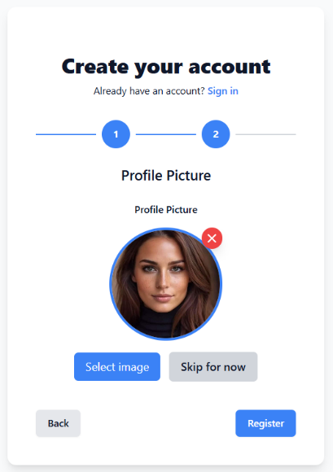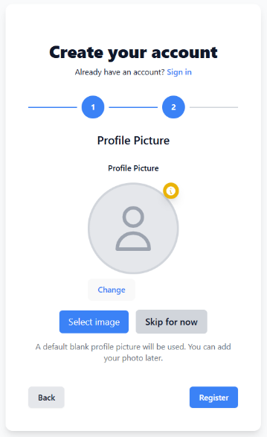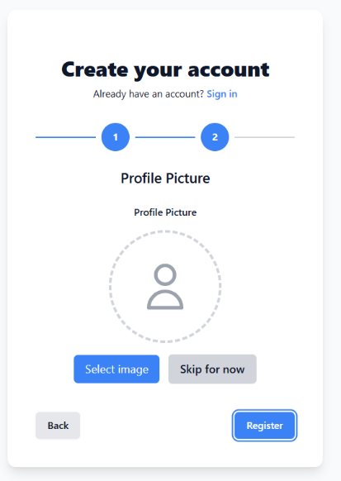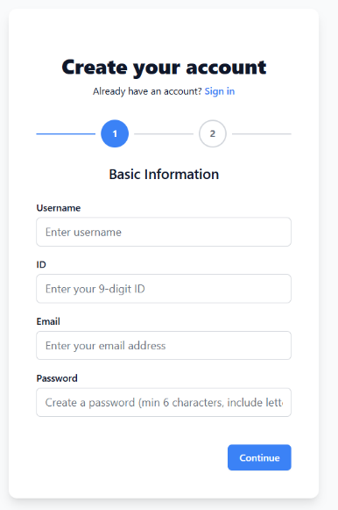

After choosing “Forgot your password?”, you’ll be asked to enter your email. A reset code will be sent to you. Then, enter a new password and confirm it on the reset page. Once submitted, your password will be updated and you’ll be automatically redirected to the login page.

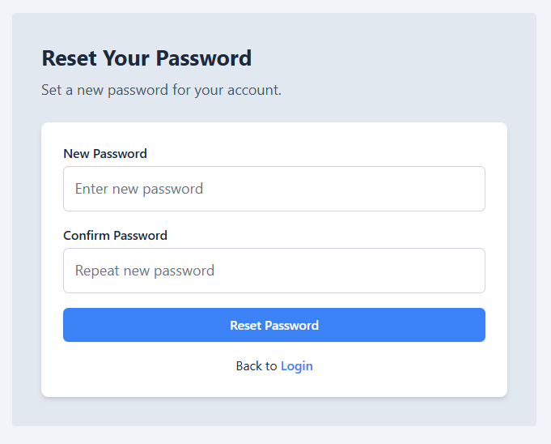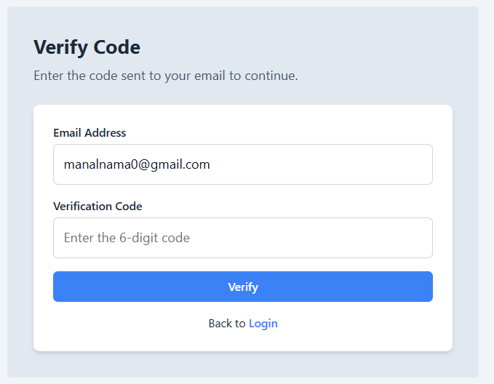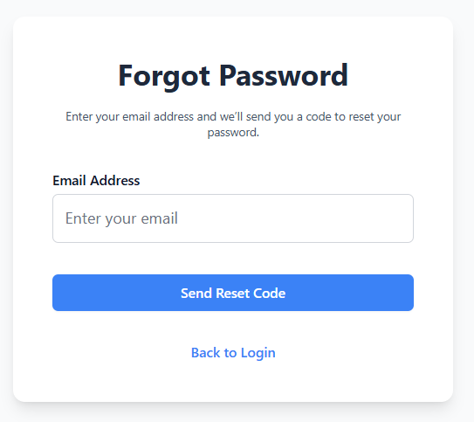

**Student's Header**

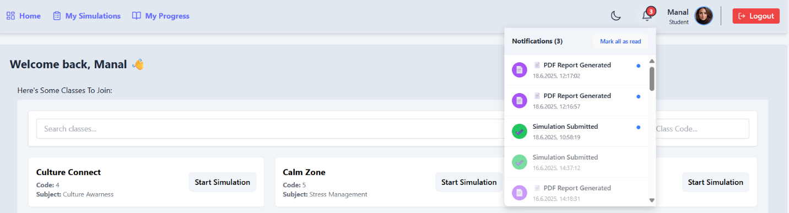 After logging in, the student header includes Home, My Simulations, My Progress, the student’s name and role, and a notification icon showing the number of unread notifications. Hovering over the icon displays recent. Each notification can be marked as read by clicking on it, or all can be marked as read using the “Mark all as read” button and a Logout button.

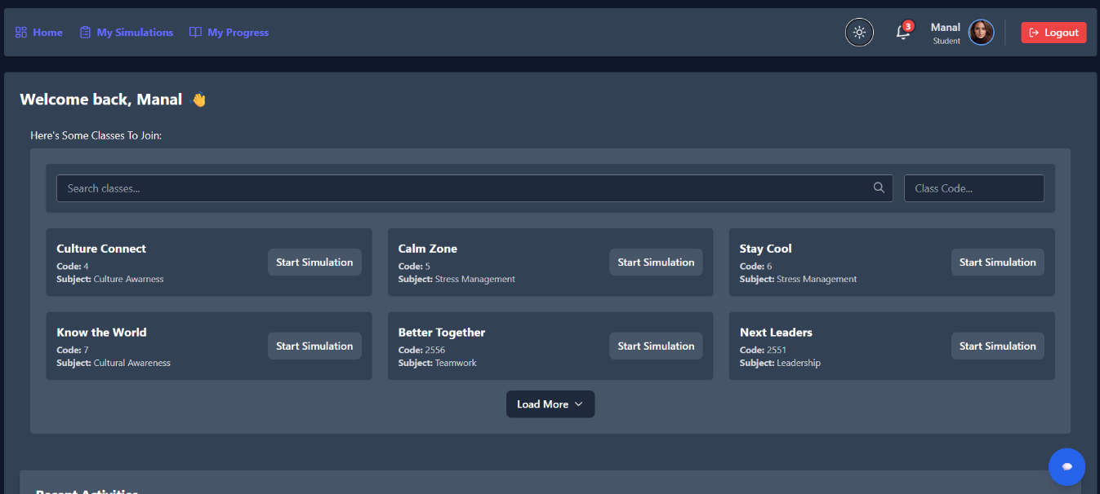The header also features a dark mode toggle to switch between light and dark themes

**ChatBot:**

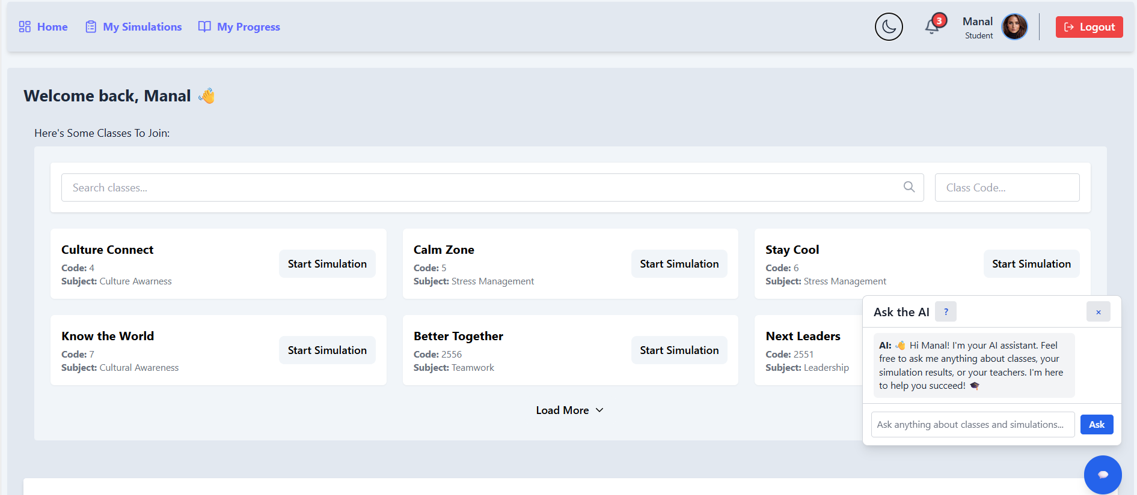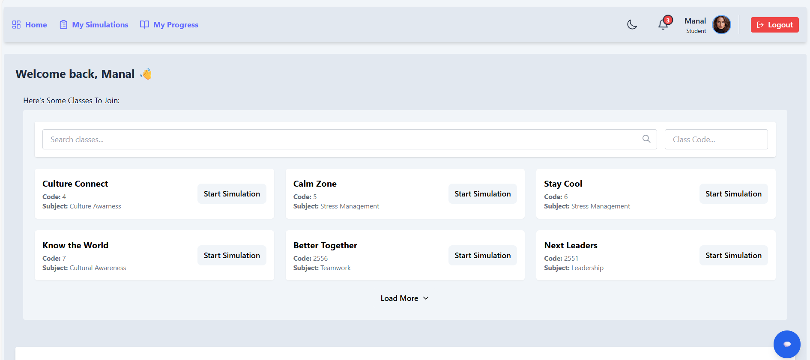Every page includes a chatbot button where the AI assistant helps with classes, simulations, progress, and more—just type your questions for instant support!

**Home:**

תמונה שמכילה טקסט, גופן, מספר, תוכנה

תוכן שנוצר על-ידי בינה מלאכותית עשוי להיות שגוי.תמונה שמכילה טקסט, גופן, מספר, קו

תוכן שנוצר על-ידי בינה מלאכותית עשוי להיות שגוי. Students are greeted with a personalized message and see a searchable list of available classes, each with a code, subject, and “Start Simulation” button.

תמונה שמכילה טקסט, גופן, צילום מסך, קו

תוכן שנוצר על-ידי בינה מלאכותית עשוי להיות שגוי.Recent activities like completed simulations and exported reports are also shown.

Clicking the **"Start Simulation"** button opens a scenario-based question where students are asked to read a social-emotional situation and submit a written response.

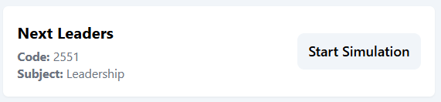

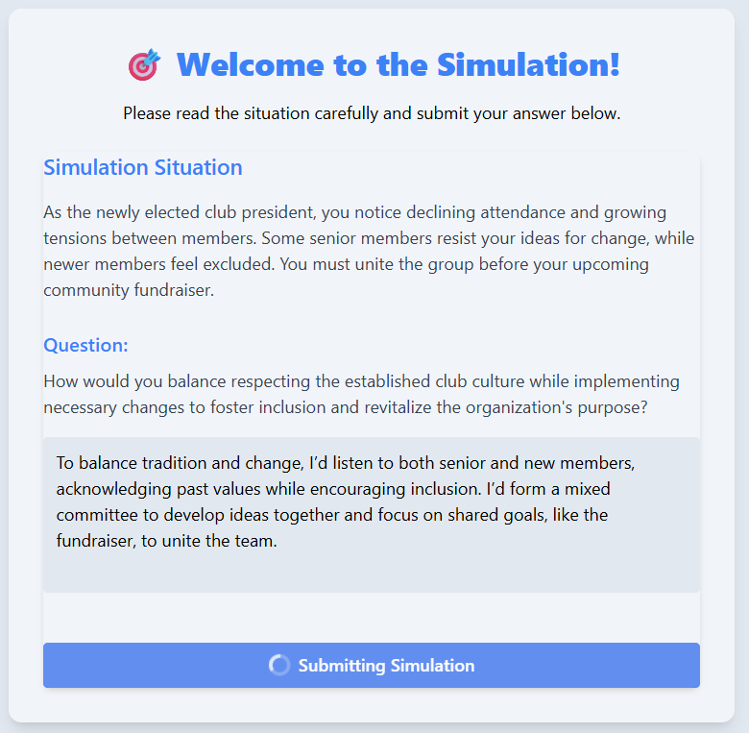

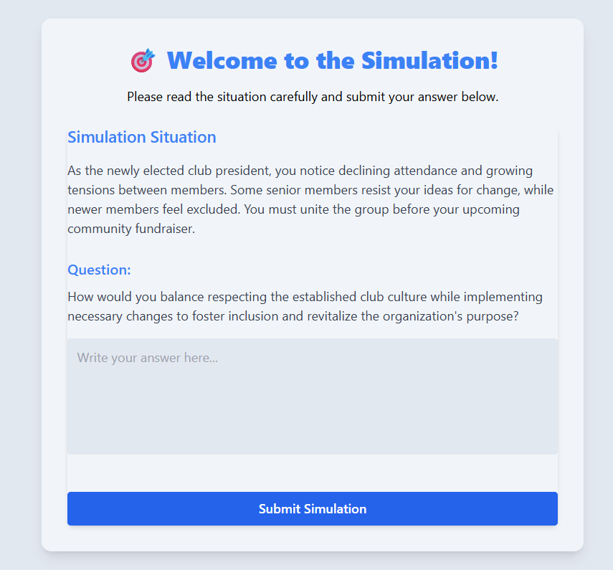

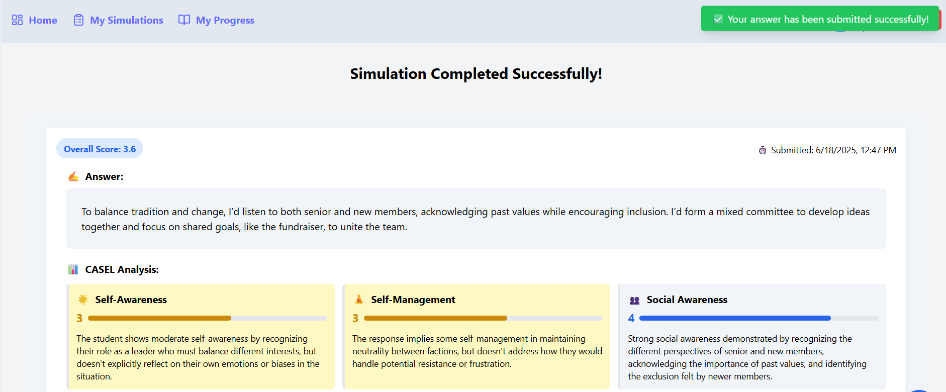After submission, the student is taken to the **Results Page**, where a notification appears: **"Your answer has been submitted successfully."**

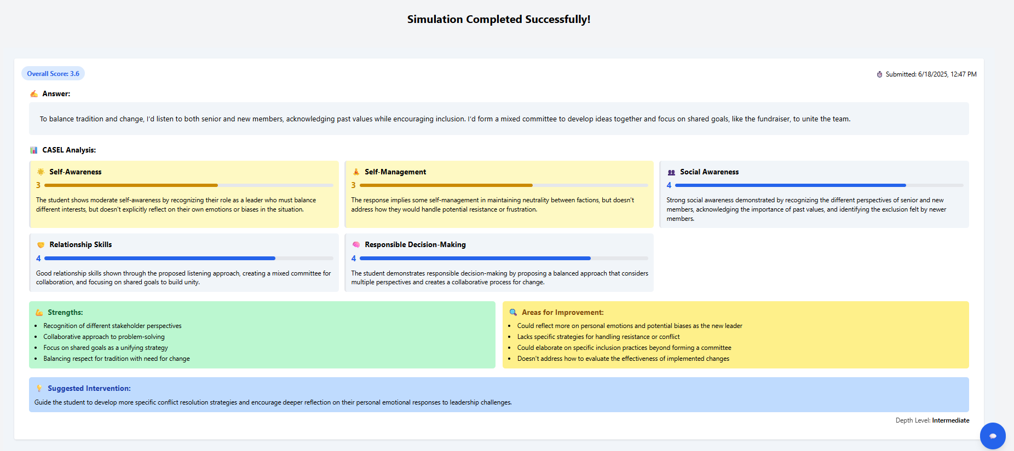The page shows their score, response, and CASEL-based feedback with strengths, improvement areas, and a suggested intervention.

**My Simulations:**

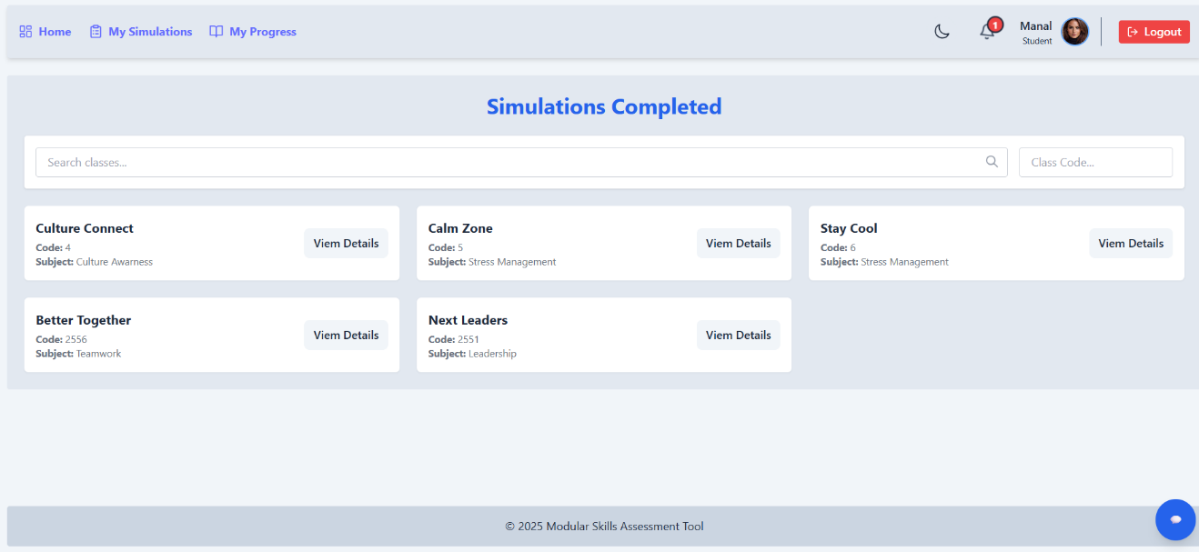Lists all the classes where the student has finished simulations. Each entry shows the class name, code, and subject topic. Students can search for specific classes using the class code and click “View Details” to review their performance and simulation results for that class.

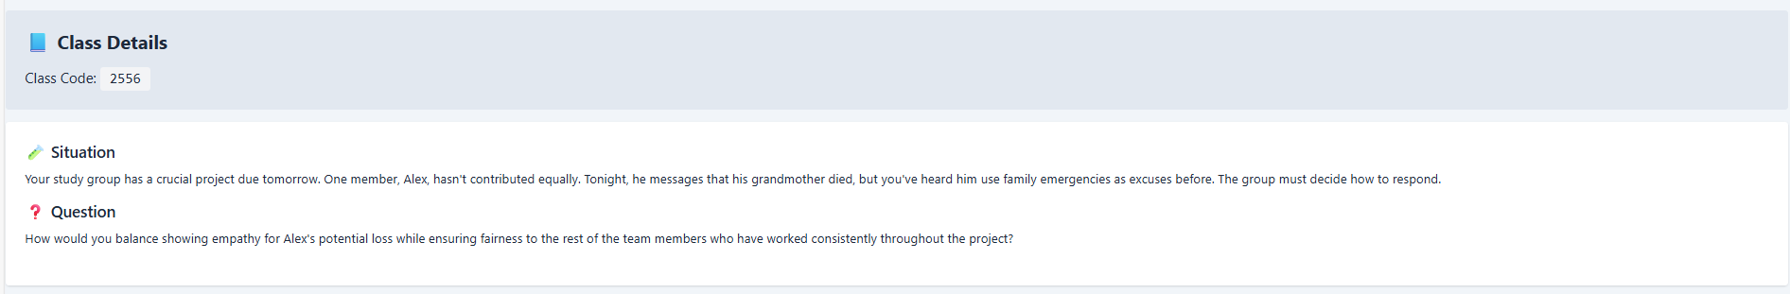 After clicking "View Details," the student sees the class code along with the full simulation scenario, including the situation and question.

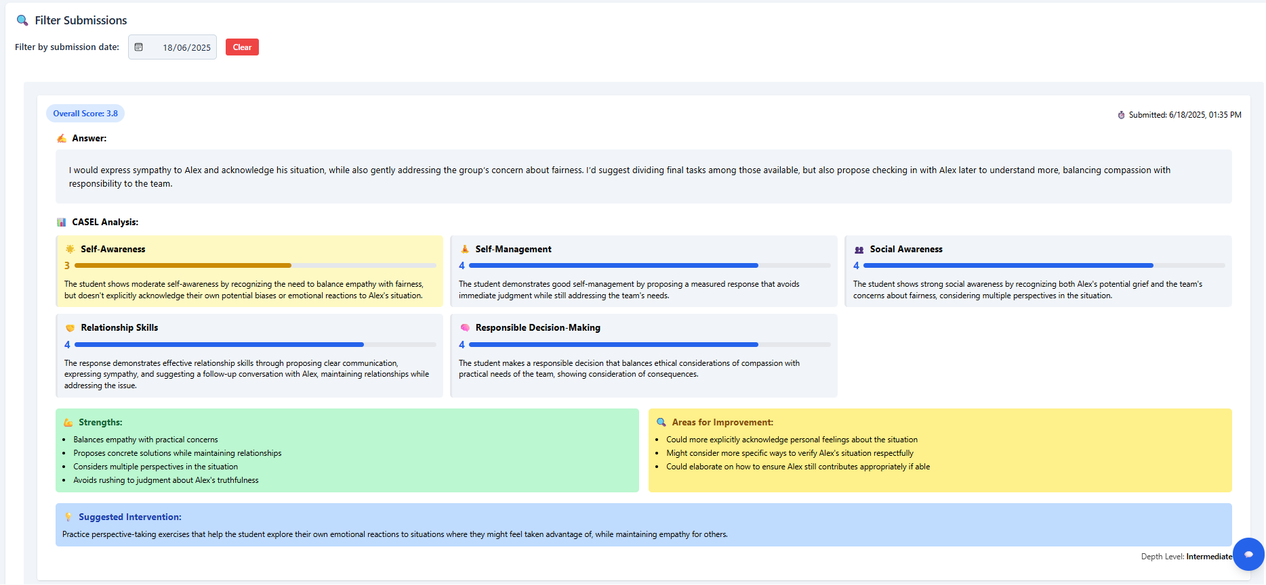They can filter submissions by date and view their overall score, submission time, and written answer. The page also shows a detailed CASEL framework analysis highlighting strengths and areas needing improvement, with suggested interventions for further support.

**My Progress:**

The **My Progress** page provides students with a personalized overview of their performance across all completed SEL (Social-Emotional Learning) simulations. It displays the student's name, ID, total submissions, number of unique simulations, and average score.

תמונה שמכילה טקסט, צילום מסך, מלבן, עיצוב

תוכן שנוצר על-ידי בינה מלאכותית עשוי להיות שגוי.The **My Progress** page displays a bar chart with the average scores for each SEL skill.

תמונה שמכילה טקסט, קו, עלילה, צילום מסך

תוכן שנוצר על-ידי בינה מלאכותית עשוי להיות שגוי.It also features a line chart tracking how these skills have changed over time based on previous simulation submissions.

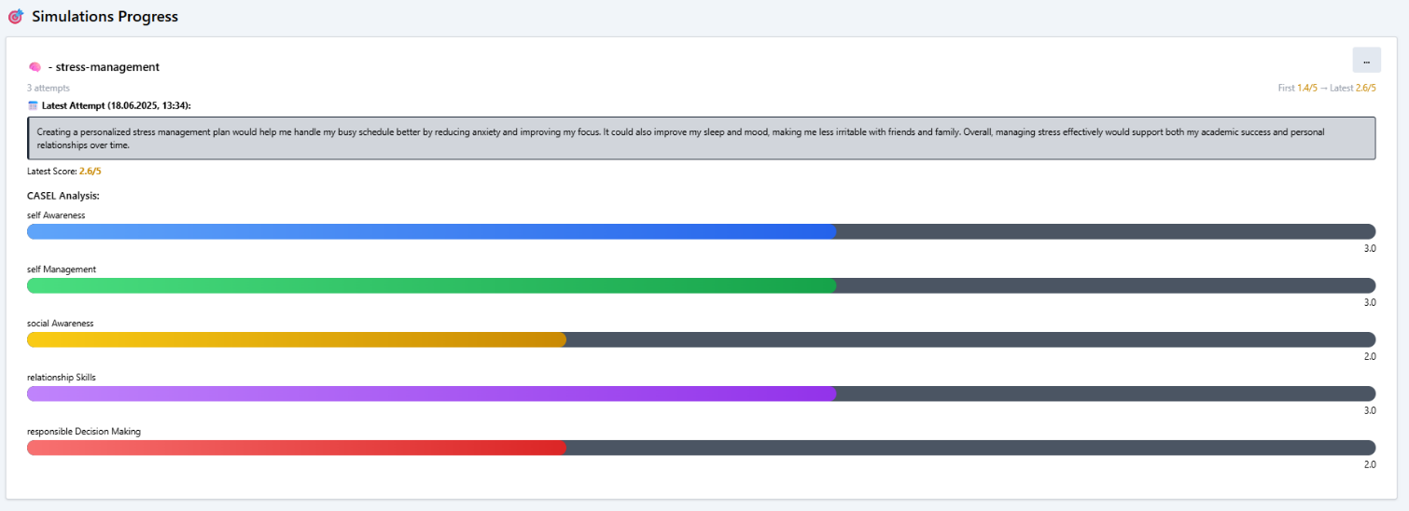Below the charts, each simulation is listed showing the number of attempts, latest submission date, most recent answer, detailed CASEL analysis for each skill, and scores from both the first and latest attempts.

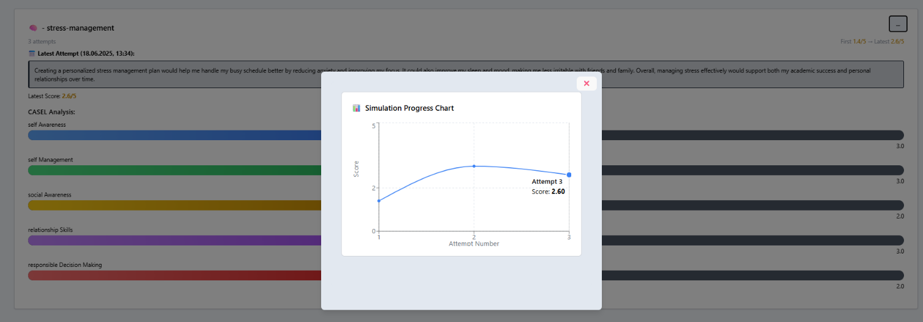  
Clicking the "..." button in each simulation opens a popup window displaying the Simulation Progress Chart, showing attempt numbers along with the score for each attempt.

תמונה שמכילה טקסט, צילום מסך, גופן, קו

תוכן שנוצר על-ידי בינה מלאכותית עשוי להיות שגוי.There is also an option to export the entire progress page as a PDF.

**Teacher's Pages:**

**Login Page:**

The Lecture Login page allows lectures to enter their ID and password to access the system. It also includes options to register for a new account or select "Forgot your password?" if needed.

The Lecture Registration is a two-step process: enter basic, then optionally upload a profile picture or skip. Finish by clicking Register. A link is available to switch to the Sign in page.



After choosing “Forgot your password?”, you’ll be asked to enter your email. A reset code will be sent to you. Then, enter a new password and confirm it on the reset page. Once submitted, your password will be updated and you’ll be automatically redirected to the login page.



**Lecture header:**

At the top of every page, a consistent header provides easy navigation across the platform. It includes links to Home, My Classes, Student Progress Overview, and Create Class, along with the teacher’s name, role, and a logout button.

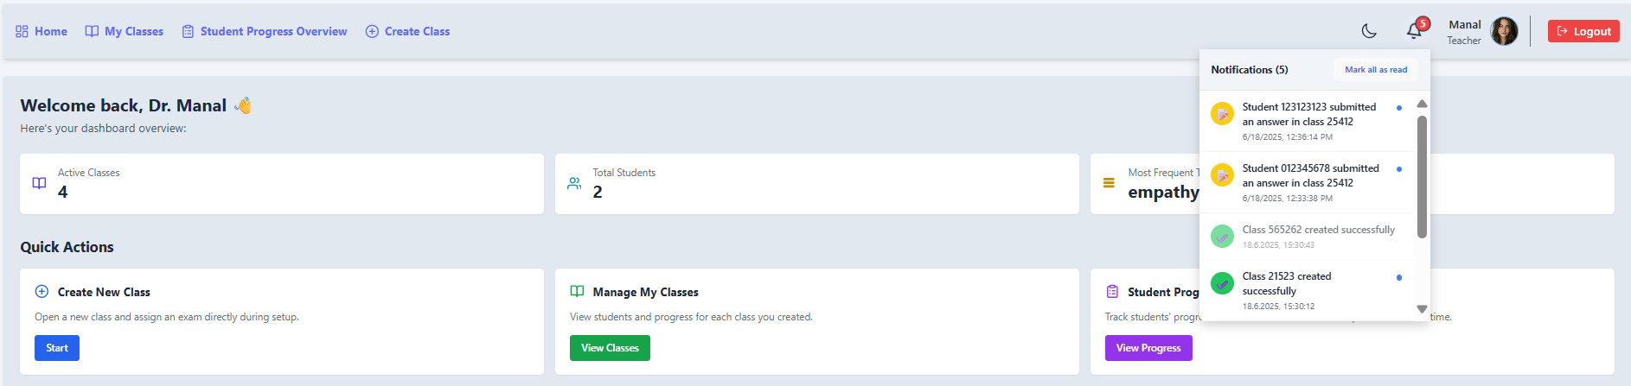 The header also features a notification icon that displays all recent updates—hovering over it opens a list where each notification can be marked as read individually or all at once using the “Mark all as read” button.

תמונה שמכילה צילום מסך, טקסט, תוכנה, תכונות מולטימדיה

תוכן שנוצר על-ידי בינה מלאכותית עשוי להיות שגוי.Additionally, users can switch between light and dark mode directly from the header to suit their visual preference.

**Home:**

On the home page, a greeting appears, followed by key stats such as the number of active classes, total students, and the most frequently used topic in simulations.

Below that, the Quick Actions section allows teachers to create a new class, manage existing classes, or track student progress across simulations.

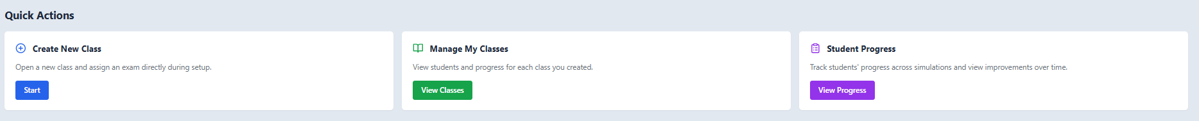Clicking on "Start**"** moves the teacher to the Create New Class page, and similarly, other buttons navigate to their respective pages.

תמונה שמכילה צילום מסך, טקסט, קו, גופן

תוכן שנוצר על-ידי בינה מלאכותית עשוי להיות שגוי.At the bottom of the page, the Recent Activities section logs recent actions to help track activity history.

**My Classes:**

תמונה שמכילה טקסט, תוכנה, מספר, גופן

תוכן שנוצר על-ידי בינה מלאכותית עשוי להיות שגוי.Lets teachers manage all their classes in one place. Each class shows its name, topic, number of students, average SEL score, and simulation attempts. Teachers can view details, check student reports, or delete a class as needed. The page also includes a "Create New Class" button at the bottom, which navigates to the Create Class page.

Clicking **"View Details"** opens the Class Details page, showing the class code, simulation situation, assigned question, and a button to view overall class performance metrics.

תמונה שמכילה טקסט, גופן, קו, מספר

תוכן שנוצר על-ידי בינה מלאכותית עשוי להיות שגוי.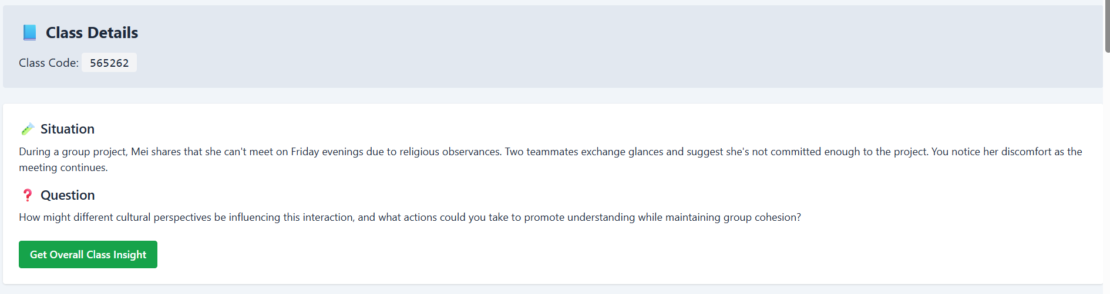A **"Get Overall Class Insight"** button allows the teacher to view aggregated performance metrics across the class.

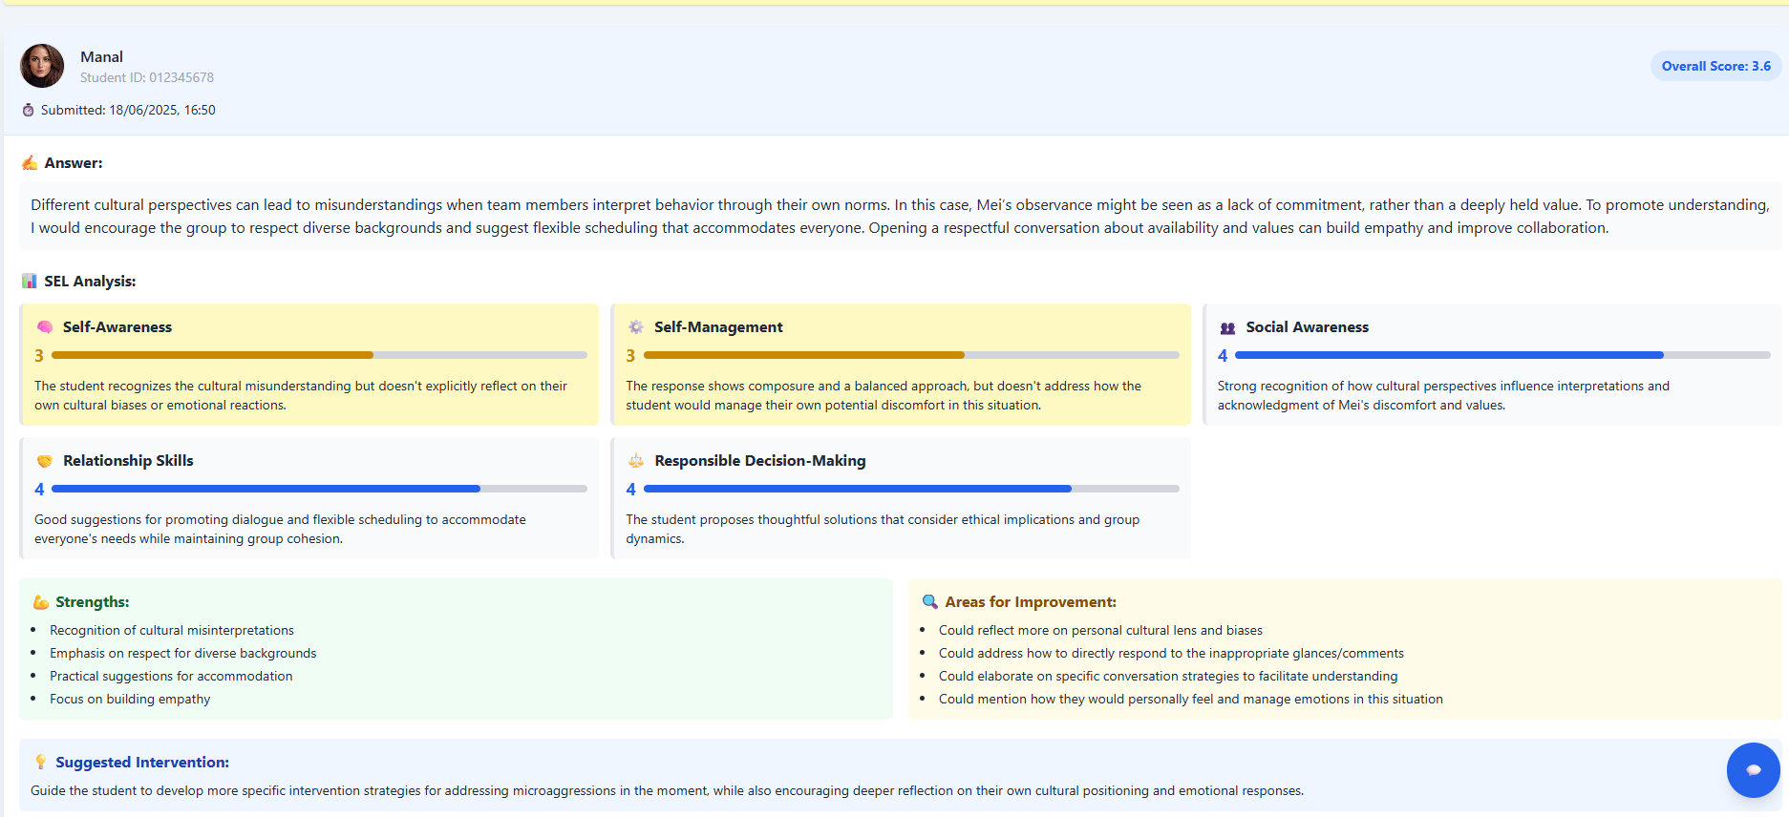Below, each student’s submission shows their name, ID, submission time, score, and response, with a breakdown of five SEL skills including scores, strengths, areas to improve, and suggested interventions.

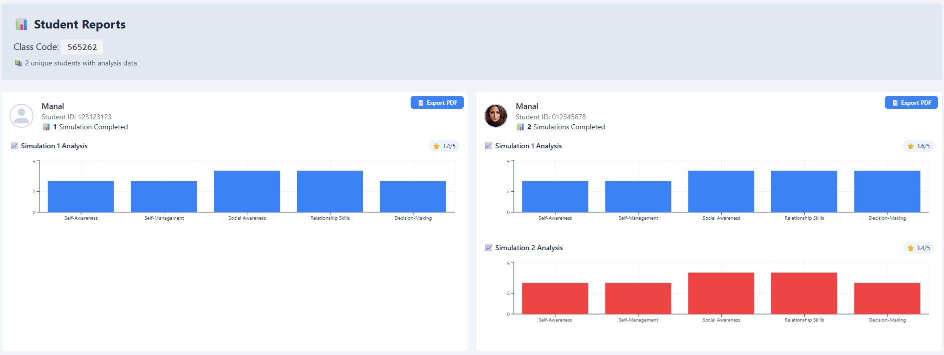Clicking **"Student Reports"** opens a page listing each student who submitted simulations in the class. For each student, it shows how many simulations they completed, their overall score for each simulation, and a graph of scores across the five SEL competencies for each simulation. There is also an option to export a PDF report for each student.

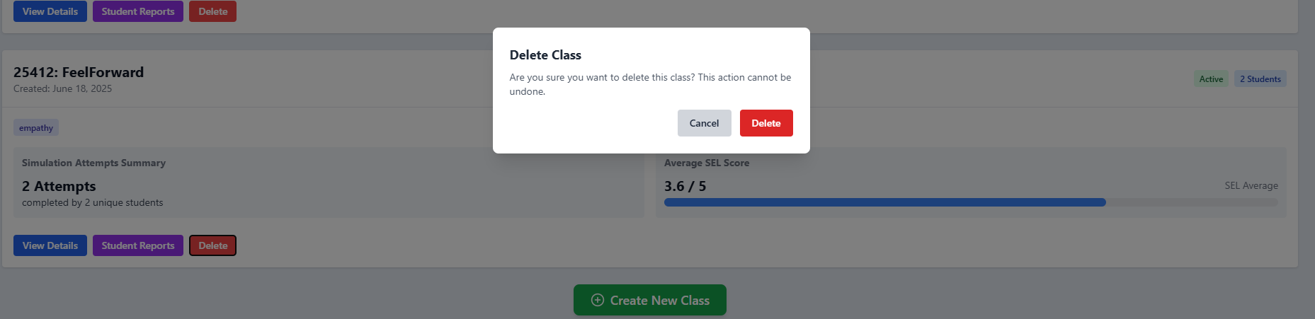Clicking the "Delete" button opens a popup window asking for confirmation to ensure the delete action.

**All Students Progress:**

תמונה שמכילה טקסט, צילום מסך, תוכנה, דף אינטרנט

תוכן שנוצר על-ידי בינה מלאכותית עשוי להיות שגוי. Displays progress for all students who participated in classes. It includes a search by Student ID. Each student entry shows their name, ID, average score, number of unique simulations completed, total attempts, latest activity date, and a "View Details" option.

תמונה שמכילה טקסט, קו, צילום מסך, תוכנה

תוכן שנוצר על-ידי בינה מלאכותית עשוי להיות שגוי.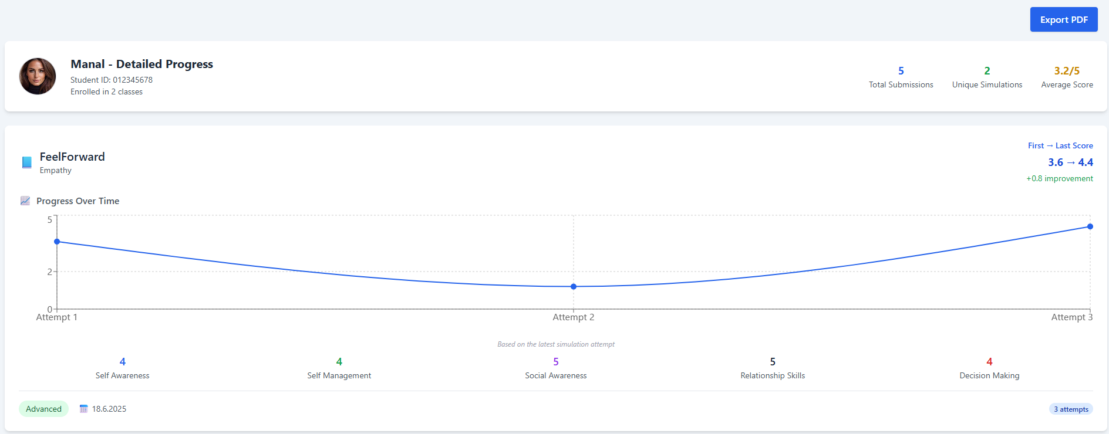The **Detailed Progress** page provides an overview of a student's performance, including enrolled classes, total submissions, unique simulations, and average score. Each simulation shows progress over time, latest SEL competency scores, and a brief summary. An **Export PDF** button allows downloading the full report.

**Create Class:**

The class setup has two steps. The first step lets teachers enter a class code, name, and topic—either from a list or custom—and generate an AI-based situation using the CASEL 5 framework by clicking “Generate Situation.” Clicking the ! button opens a popup explaining how it works.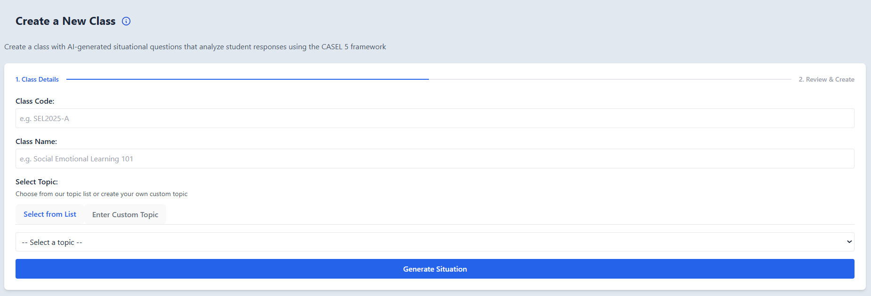תמונה שמכילה טקסט, תוכנה, צילום מסך, תכונות מולטימדיה

תוכן שנוצר על-ידי בינה מלאכותית עשוי להיות שגוי.



Choosing topic from a list or entering a custom one תמונה שמכילה טקסט, צילום מסך, גופן, קו

תוכן שנוצר על-ידי בינה מלאכותית עשוי להיות שגוי.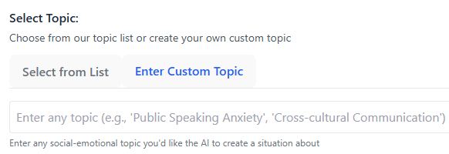:

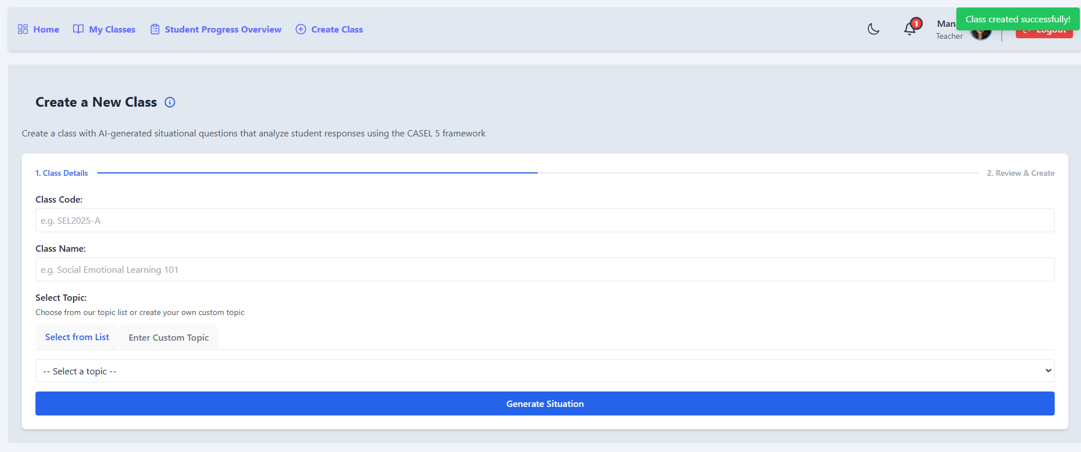תמונה שמכילה טקסט, תוכנה, דף אינטרנט, סמל מחשב

תוכן שנוצר על-ידי בינה מלאכותית עשוי להיות שגוי.After clicking "Generate Situation," the teacher moves to the second step, where they review the AI-generated situation and question before finalizing the class. They can regenerate the scenario, approve and create the class, or go back to edit details. Upon approval, the teacher moved utomatically back to the create class page and a “Class Created Successfully” notification appears at the top.